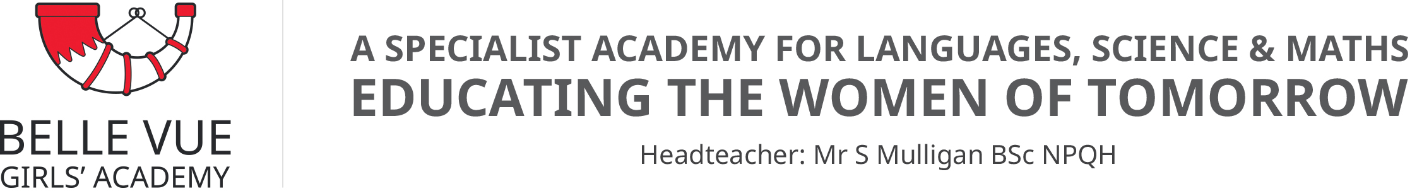
October 2021

Dear Parent/Carer

Y11 Parents’ Evening - Online Appointment Booking

I would like to invite you to attend our Parents’ Evening on Wednesday 1st December. This is an important evening and provides you with the opportunity to speak to your daughter’s individual GCSE subject teachers face to face in school. During the meeting you will have the chance to ask about your daughter’s current progress and discuss any issues or concerns that you may have regarding her studies.
The school has introduced a new and easy to use online appointment booking system. This allows you to choose your own appointment times with teachers and you will receive an email confirming your appointments. With Covid restrictions lifted we can now hold Parental Consultation evenings back in school and meet face to face.

Appointments can be made as soon as you receive this letter.

Please visit https://bellevue.schoolcloud.co.uk/ to book your appointments. (A short guide on how to add appointments is included with this letter.) These documents and a direct link to School Cloud are also available on the school’s website – see the section under the Parents tab labelled Parents’ Evenings.
Login with the following information:

Your personal Login code – which you will receive in a separate communication. You will already have this from last year but we’ll send out a reminder.
Your daughter’s Date of Birth

If you do not have access to the internet, please contact the school office who will be happy to add appointments on your behalf.

If you have any queries concerning this event, then please contact Mrs Clarke, Head of Year 11 or Miss Bashir, Y11 Pastoral Manager, on 01274 492341.

Yours sincerely

H Michaels

Hal Michaels
Assistant Head

