**Belle Vue Girls’ Academy Alumni Profile**

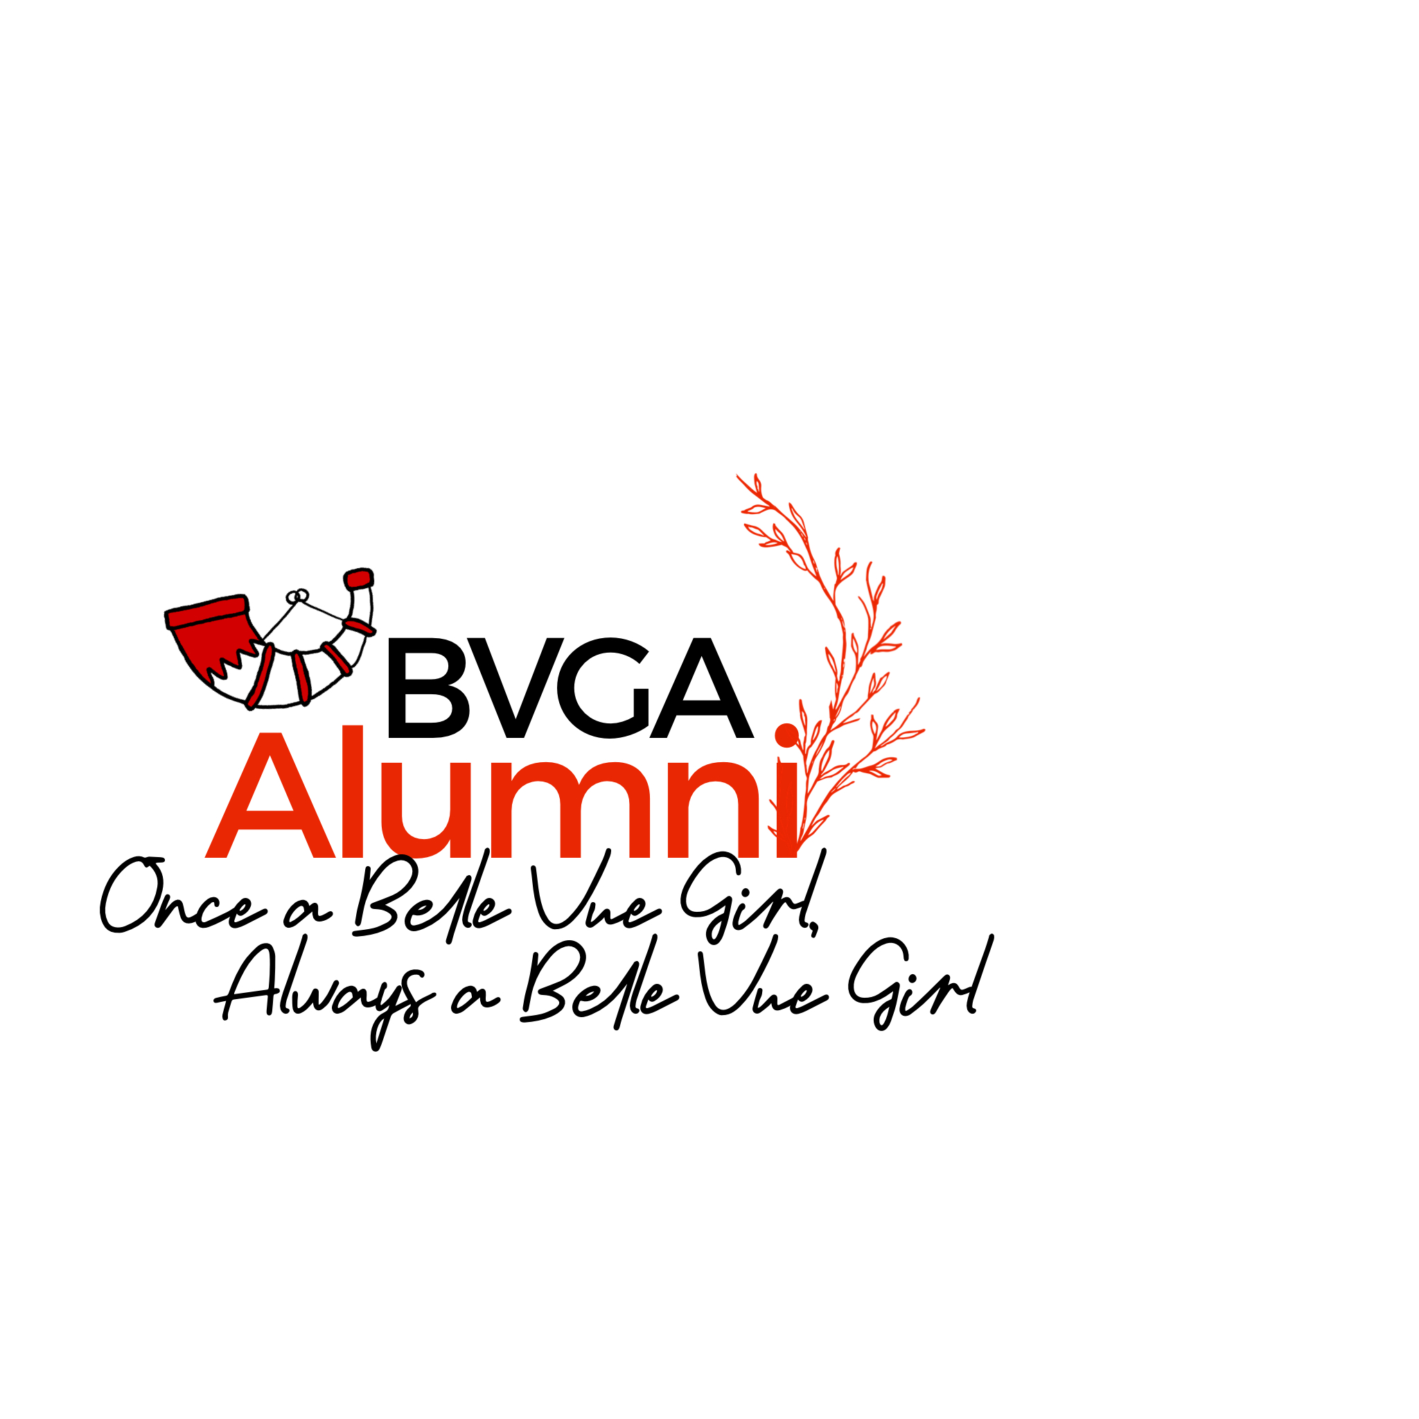

|  |  |  |  |
| --- | --- | --- | --- |
|  | **Full Name** | **Current Role** | **Telephone number** |
| **Address** |  |  |  |
| **Email Address** |  | | |
| **How did you hear about the BVGA alumni?** |  | | |
| **Current connections/links to the school** | Are you connected to any staff/students currently at BVGA?  Please provide names and role/year group. | | |
| **Year left BVGA** |  | | |
| **Achievements and accomplishments at school** | (Academic, personal, sporting, artistic) | | |
| **Achievements and accomplishments upon leaving school** | (university, subject, profession, apprenticeships, employment, business endeavours) | | |
| **Any other experiences you would be interested in sharing** | (hobbies, interests, expertise, charity work) | | |
| **Would you be happy to feature on the school website as a BVGA alumni advocate?** |  | | |
| **Personal circumstances** | Please feel free to add anything you would like us to know about you personally. There may have been personal experiences that you would like us to know about so you can support specific sub-groups of students. These may include: **disability, being a young carer, having English as an additional language** etc. These **will not** be shared without your consent. | | |
| **Please email to** | [mehwash.kauser@bvga.bdat-academies.org](mailto:mehwash.kauser@bvga.bdat-academies.org) | | |